An End-to-End Travel Approval App with SAP CAP, HANA Cloud, and SAP Build Process Automation

Goal
The goal is to build a working Travel Approval application, not just a collection of disconnected demos. A user creates a travel request in a Fiori Elements application. The CAP service stores the request in SAP HANA Cloud and automatically starts an SAP Build Process Automation workflow.
The approver reviews the task in My Inbox and selects Approve or Reject, updating the corresponding Travel record in HANA Cloud.

Create Travel in Fiori
↓
CAP saves the active record in HANA Cloud
↓
CAP starts the BPA workflow automatically
↓
Approval task appears in SAP Build Lobby->My Inbox
↓
Approve → overall_status = A
Reject → overall_status = R
↓
Validate in Fiori, SAP Build->Monitoring, and HANA Database Explorer

Prerequisites
BTP Service / instance required
SAP Business Application Studio
SAP HANA Cloud
SAP Build Process Automation

The End-to-End Flow
- Create Travel entity in CDS.
- Expose the entity as a draft-enabled OData V4 service.
- Generate the Fiori Elements application.
- Bind the CAP project to the HANA HDI container.
- Build the MTA archive and deploy it to Cloud Foundry.
- Download the CAP metadata as an EDMX specification.
- Create SAP Build Actions from the EDMX and test the OData operations.
- Create the Travel Context, API trigger, Approval Form, and approval branches in BPA.
- Create a BPA service key and an API key with trigger execution permission.
- Add the CAP SAVE handler that starts the workflow automatically.
- Test from Fiori, process the task in My Inbox, monitor the instance in Build Lobby, and validate the final status in HANA.

1. Model the CDS Entity for the CAP OData V4 Service
The CDS entity is the source of truth for the Travel data. The technical UUID and the business Travel ID form the key used by the draft-enabled service and by the generated SAP Build Actions.
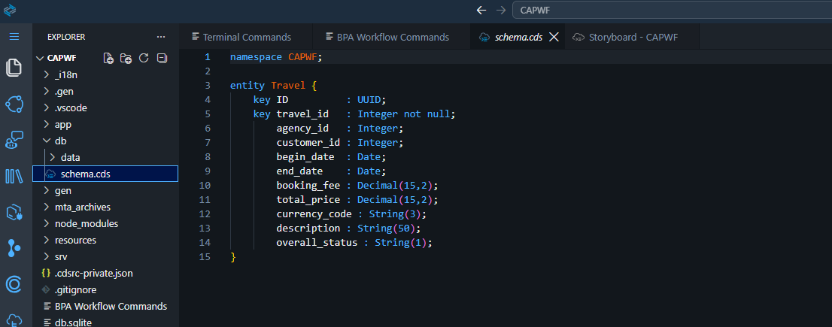

Expose the Travel entity as a service
Create file srv/service.cds.
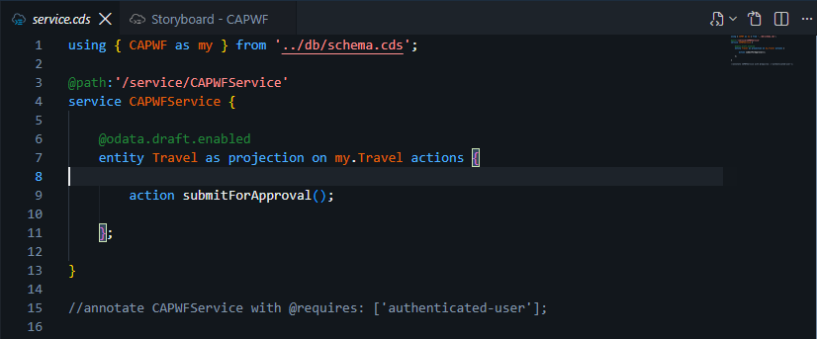
Why draft support matters: Fiori Elements creates and edits a draft first. The active Travel record is produced when the user activates or saves the draft. The CAP SAVE event is therefore the reliable point for starting the workflow.

2. Create the Fiori Elements App
Generate a List Report/Object Page application for CAPWFService.Travel. The list lets users create requests and review the current status. The Object Page captures the full Travel details.

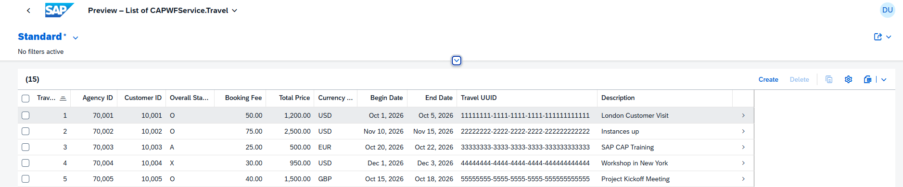
Figure 1. Fiori List Report with Travel IDs in ascending order.

3. Connect to Cloud Foundry

Cloud Foundry provides the runtime for the deployed CAP service. Log in from the BAS terminal and select the correct organization and dev space.
cf login
cf target

Before testing SAP Build Actions, always confirm that the deployed CAP application is running:
cf start CAPWF-srv
cf app CAPWF-srv

Expected status:
requested state: started
instances: 1/1
state: running
Important: When CAPWF-srv was stopped, every SAP Build Action returned 404 Requested route does not exist. Starting the application restored the Actions immediately.

4. Bind to a HANA Cloud HDI Container
An HDI container is an application-scoped database container. It gives the CAP application its own isolated schema inside the HANA Cloud database.
cds bind --to CAPWF-db
cds env get requires.db --profile hybrid
The hybrid profile must show the CAPWF-db instance. Start the local service against HANA:
pkill -f cds
cds watch --profile hybrid
Look for connect to db > hana and the expected HANA schema in the terminal output.

Lesson learned: The lowercase capwf-db and uppercase CAPWF-db were two separate service instances. Local Fiori and deployed BPA initially showed different record counts because they were connected to different HDI containers.

5. Generate the MTAR File
The Multi-Target Application archive packages the service, database deployer, security resources, destinations, and HTML5 content into one deployable unit.
mbt build
The archive is generated under:
mta_archives/CAPWF_1.0.0.mtar

6. Deploy to HANA Cloud and Cloud Foundry
cf deploy mta_archives/CAPWF_1.0.0.mtar
The deployment runs the database deployer, binds CAPWF-srv to CAPWF-db and CAPWF-auth, and starts the application route.
cf app CAPWF-srv
cf routes
cf logs CAPWF-srv --recent
Free-tier note: Stopping applications frees runtime memory, but it also makes the CAP route unavailable. Start CAPWF-srv again before testing browser URLs or SAP Build Actions.

7. Connect to the HANA DB Explorer and Add the HDI Container

Open SAP HANA Database Explorer.

Choose Add Database or Add HDI Container.

Select the CAPWF-db HDI container.

Expand Catalog and Tables.

Open the Travel table data and compare the record count with the Fiori app.

After approval or rejection, refresh the table and verify overall_status.
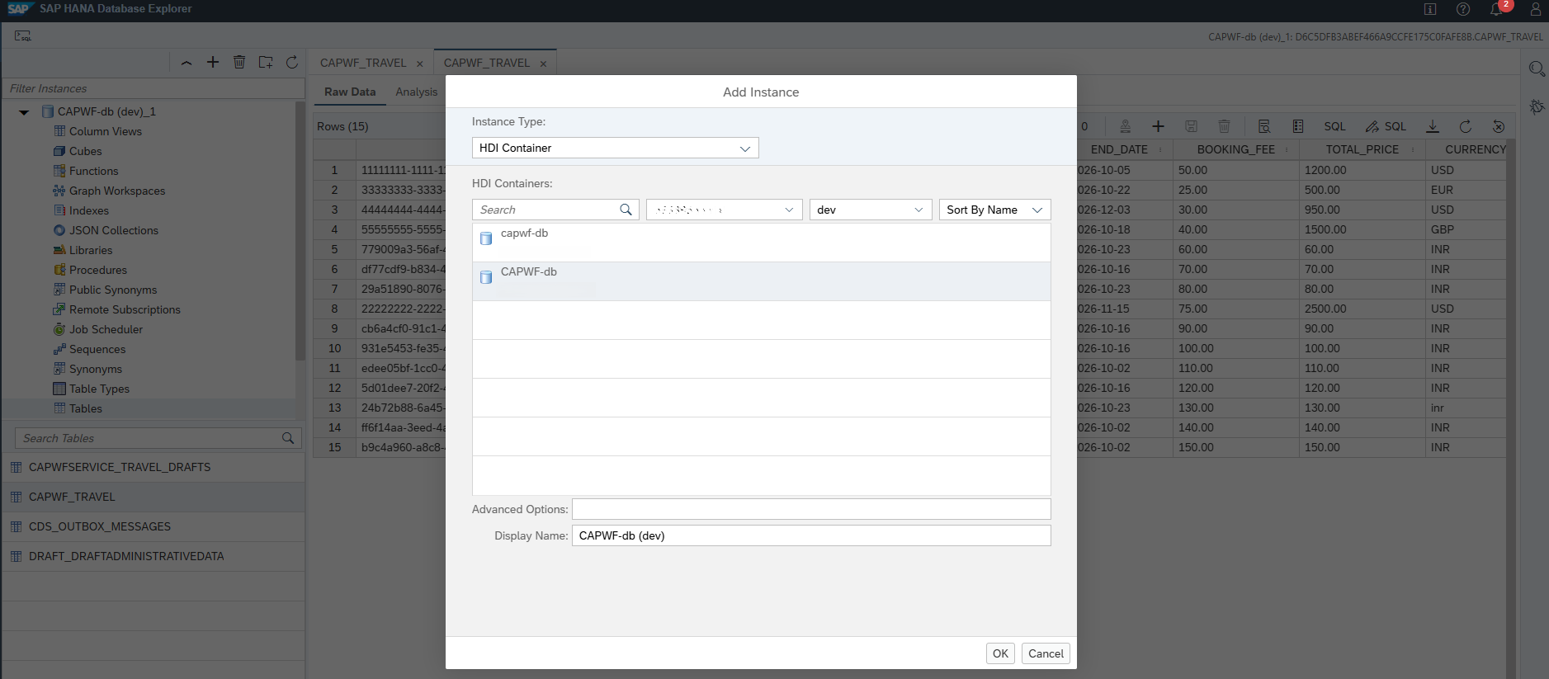
Figure 2. CAPWF-db added to SAP HANA Database Explorer.

8. Download the Metadata File as EDMX
The metadata document describes the OData V4 service, entity fields, keys, draft properties, and custom actions. SAP Build uses this specification to generate reusable Actions.
/service/CAPWFService/$metadata
Open the metadata->right-click->Save as .edmx file
Open the local BAS port 4004 metadata URL, save the XML as CAPWFService.edmx, and verify that it contains:
- EntitySet Name="Travel"
- The Travel entity fields and keys
- Draft operations
- Action Name="submitForApproval" IsBound="true"

9. Create SAP Build Actions

Open SAP Build Lobby -> Actions -> Create.

Choose Upload API Specification.

Upload CAPWFService.edmx.

Create the Action project CAPWFService3.

Select the required Travel operations. The POC selected all 13 generated operations.

Open Settings and configure the destination and URL prefix.
Setting | Value
Destination | CAPWF-srv
URL Prefix | /service/CAPWFService
CSRF | Disabled for this POC
Destination authentication | OAuth2ClientCredentials
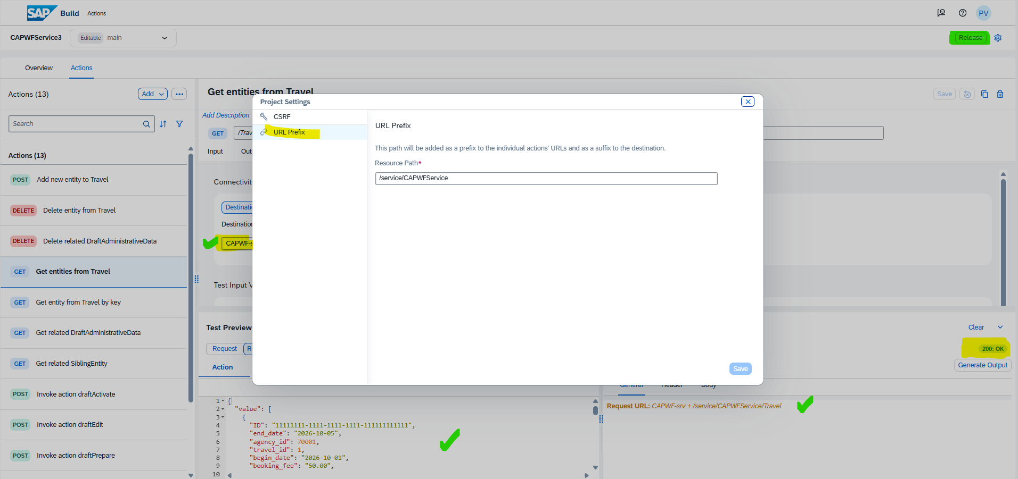

Test the Actions before publishing

Get entities from Travel should return 200 OK and all records. - see the image below

Get entity from Travel by key should return the selected record using ID, travel_id, and IsActiveEntity=true.

Update entity in Travel should be validated independently before adding it to the process.

Release and Publish only after direct tests succeed.
Troubleshooting shortcut: If all Actions suddenly return 404 and no request reaches, run the below commands in new Terminal.
- cf logs CAPWF-srv
- cf app CAPWF-srv
- cf start CAPWF-srv -->You can see the Instances are up and Running 1/1
- The root cause may simply be a stopped application.

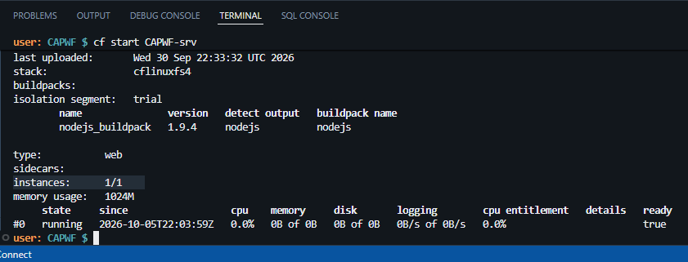
Figure 2. CAPWFService3 Action test returning 200 OK.

12. Steps in SAP Build Process Automation

Create the project and artifacts

Create the project RAP110_Travel_Workflow.

Create the process of Travel Approval Processing.

Create the Travel Context datatype.

Create a Travel Approval Trigger as an API trigger.

Create the Approval Form and map the Travel fields.

Add Approve and Reject outcomes.

Add Update entity in Travel from the published CAPWFService3 dependency.

Map the keys and set overall_status to A in Approve and R in Reject.
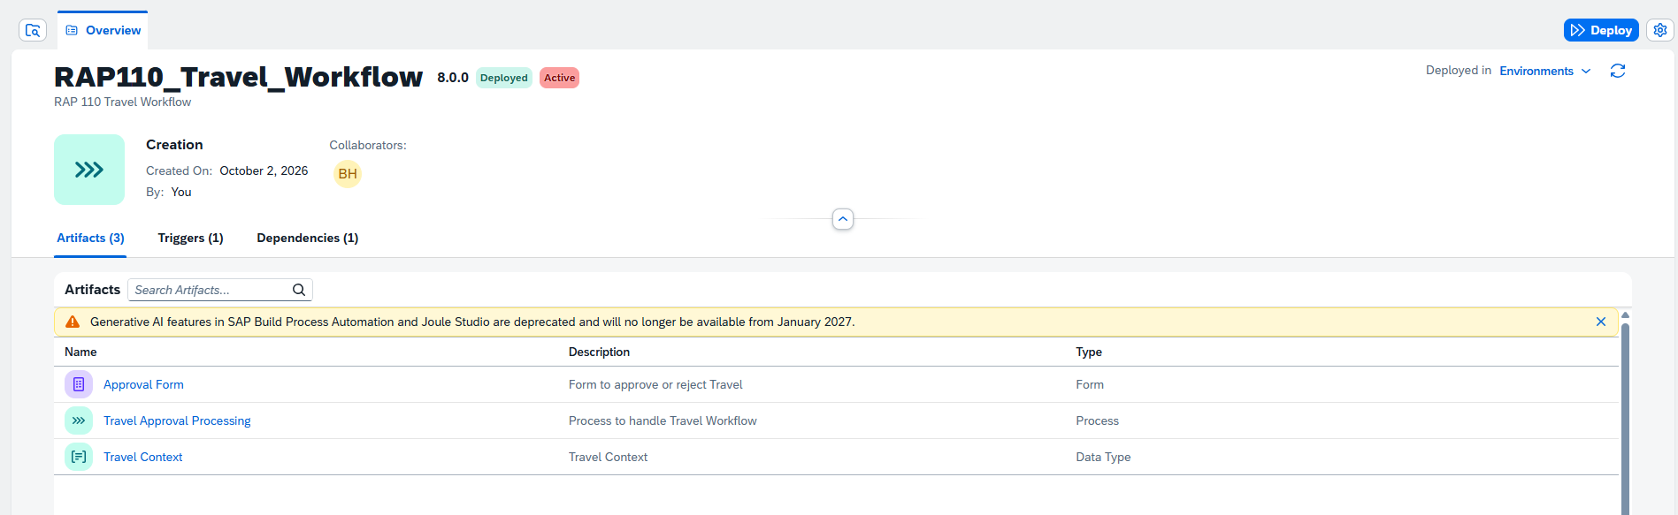
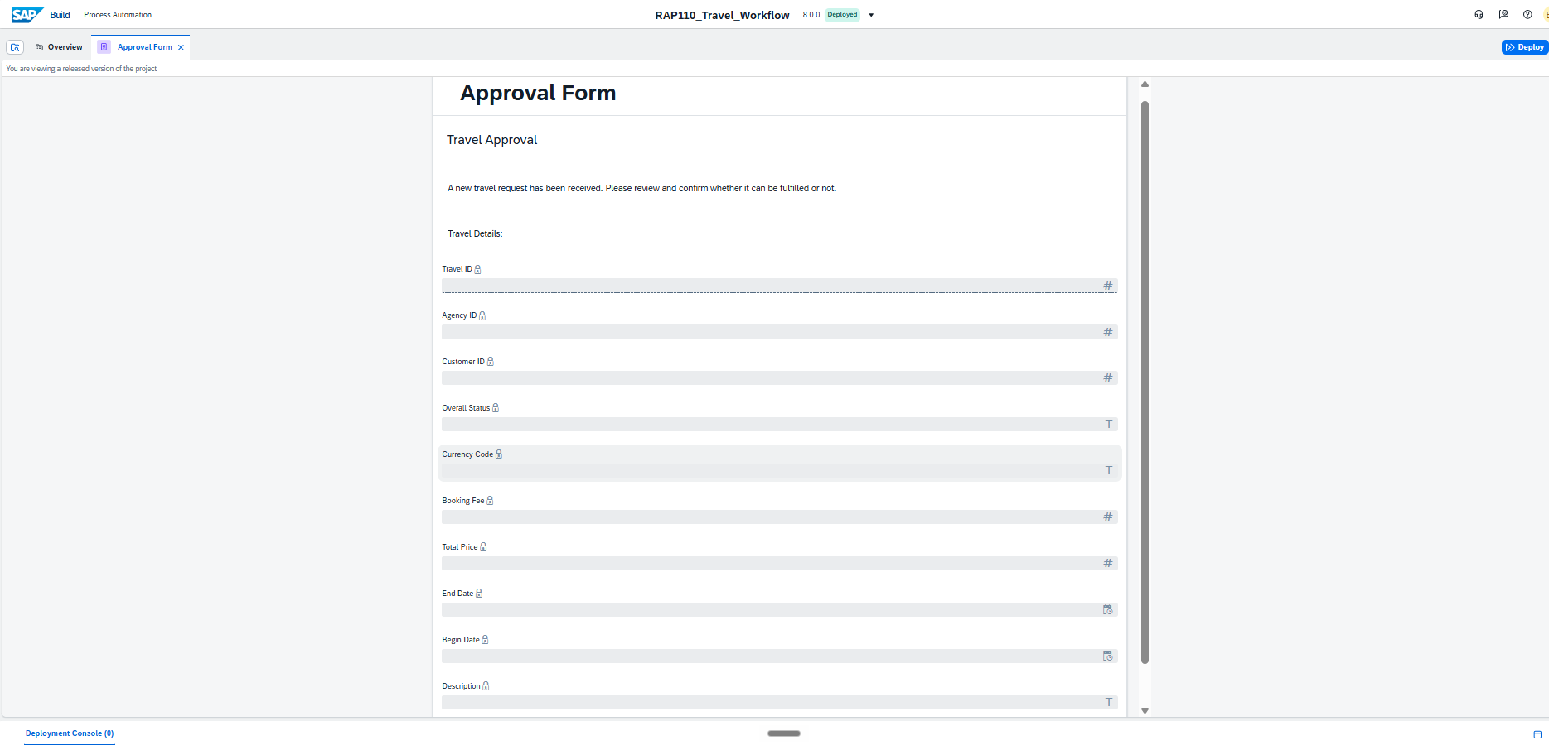
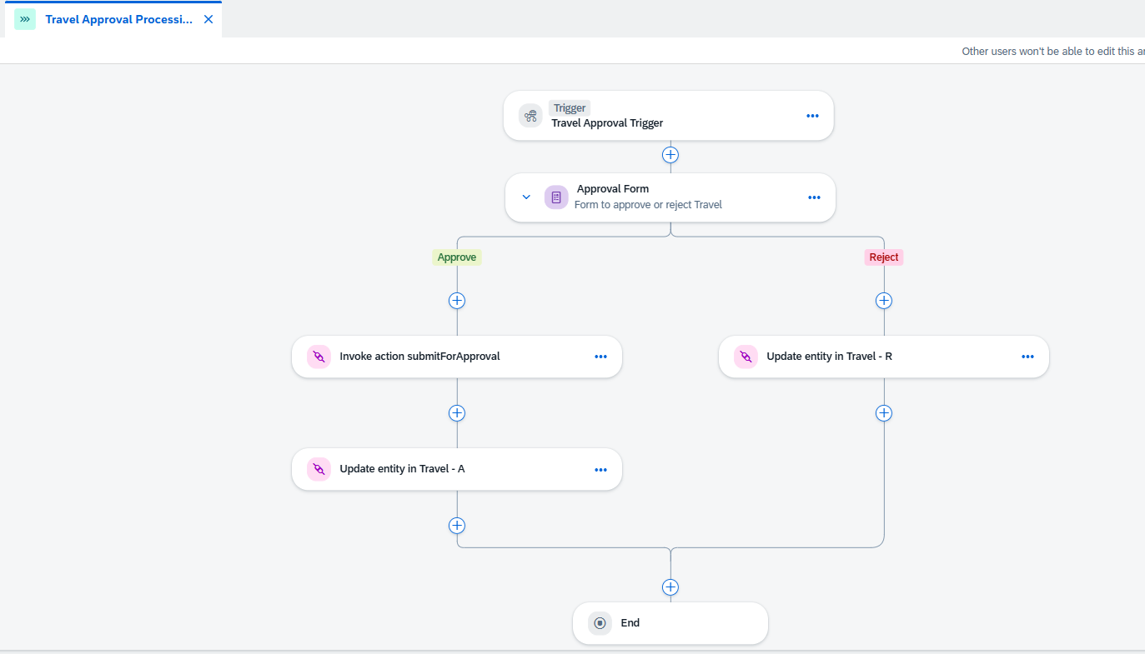

13. Travel Context fields
Field | Type
TravelUUID | String
TravelID | Number
IsActiveEntity | Boolean
agency_id | Number
customer_id | Number
begin_date | Date
end_date | Date
booking_fee | Number
total_price | Number
currency_code | String
description | String
overall_status | String

14. Approval Form recipient
When a human starts the workflow manually, Started By is the signed-in user. When CAP starts the process using client credentials, Started By is a technical client. For the POC, the Approval Form recipient was set to the intended email address, so the work item appeared in My Inbox. A production design should pass an ApproverEmail value or determine the approver through business rules.

15. Add and Delete Dependencies

A process can use only released and published Action projects through Dependencies.

Open the editable BPA project and switch to Dependencies.

Add the published CAPWFService3 Action project.

If an old Action dependency is removed, delete any orphaned process nodes that show blank Inputs.

Re-add the Actions from CAPWFService3 and remap their inputs.

To remove a dependency, select it, choose Settings, and select Delete.

If an Action project cannot be deleted, remove consuming dependencies and delete its released versions first.

16. Create an API Key in SAP Build
The CAP application starts the process as a technical client. It therefore needs both OAuth client credentials and an SAP Build API key that is authorized to execute the trigger.

Open SAP Build -> Control Tower -> API Keys, or Public Environment -> API Keys.

Choose Add API Key.

Enter a meaningful name, such as CAPWF_Auto_Start.

Select the Public environment.

Enable trigger_execute. This is the minimum scope needed to execute the API trigger.

Create the key and copy it immediately. The value is displayed only once.

17. Build Process Automation - Manual Workflow Test Using the Payload
Before automating the trigger from CAP, manually prove the deployed process and payload schema.

Open Control Tower -> Environments -> Public -> Triggers.

Open Travel Approval Trigger.

Choose Start New Instance.

Paste only the process context expected by the dialog, with travelContext as the root object.

Start the instance and confirm it appears in Monitoring.

Open My Inbox and process the task.

Confirm the instance completes and the Travel status is updated.
{
"travelContext": {
"TravelUUID": "<UUID>",
"TravelID": 15,
"IsActiveEntity": true,
"agency_id": 70015,
"customer_id": 70015,
"begin_date": "2026-10-02",
"end_date": "2026-10-16",
"booking_fee": 150,
"total_price": 150,
"currency_code": "INR",
"description": "Travel request",
"overall_status": "W"
}
}

18. List of Terminal Commands to Get BPA Keys
cf create-service-key BPA cap-bpa-key
cf service-key BPA cap-bpa-key
From the BPA service key, record these values securely: clientid, clientsecret, and url. The token endpoint is the URL value plus /oauth/token.
Do not mix credentials: CAPWF-auth credentials protect the CAP application. BPA service-key credentials authenticate the call to SAP Build Process Automation. Using CAPWF-auth credentials caused 401 invalid_client / Bad credentials.

19. Start the Workflow Automatically from CAP
The Fiori application activates a draft when the user saves a new Travel. CAP handles that lifecycle through the SAVE event. The handler builds the exact trigger payload, obtains an OAuth token, sends the BPA API key, and creates the workflow instance.
// create a file in srv/service.js

this.after('SAVE', 'Travel', async (data, req) => {
const travel = req.data;
const workflowPayload = {
definitionId:
'us10.e66895ddtrial.rap110travelworkflow.travelApprovalProcessing',
context: {
travelContext: {
TravelUUID: travel.ID,
TravelID: travel.travel_id,
IsActiveEntity: true,
agency_id: travel.agency_id,
customer_id: travel.customer_id,
begin_date: travel.begin_date,
end_date: travel.end_date,
booking_fee: Number(travel.booking_fee),
total_price: Number(travel.total_price),
currency_code: travel.currency_code,
description: travel.description,
overall_status: travel.overall_status
}
}
};
// 1. Get an OAuth token with BPA client credentials.
// 2. POST workflowPayload to BPA_WORKFLOW_URL.
// 3. Send Authorization: Bearer <token> and api-key headers.
});

20. Verify in BAS with Three Terminals

Terminal 1 - Run local CAP with BPA credentials
echo $BPA_CLIENT_ID
echo $BPA_CLIENT_SECRET
echo $BPA_TOKEN_URL
echo $BPA_API_KEY
echo $BPA_WORKFLOW_URL

run the below commands with the above values:

export BPA_CLIENT_ID='<BPA service-key clientid>'
export BPA_CLIENT_SECRET='<BPA service-key clientsecret>'
export BPA_TOKEN_URL='<BPA service-key url>/oauth/token'
export BPA_API_KEY='<SAP Build Public environment API key>'
export BPA_WORKFLOW_URL='https://spa-api-gateway-bpi-us-prod.cfapps.us10.hana.ondemand.com/workflow/rest/v1/workflow-instances'
pkill -f cds
cds watch --profile hybrid

Terminal 2 - Confirm the deployed CAP app is running
cf start CAPWF-srv
cf app CAPWF-srv

Terminal 3 - Watch deployed CAP requests
cf logs CAPWF-srv

A successful automatic start prints:
BPA workflow started for Travel 5
Workflow instance ID: <generated instance ID>
Session behavior: The export commands apply only to the current terminal session.
After BAS signs out or a new terminal is opened, export the variables again before cds watch.

21. Test Directly from the Fiori Application

Confirm Terminal 1 has BPA environment variables, and cds watch is running.

Confirm CAPWF-srv is 1/1 running if the workflow will call CAP through SAP Build Actions.

Open the Fiori Preview.

Create a new Travel record with overall_status W.

Save the record.

Watch Terminal 1 for the workflow instance ID.

Open SAP Build My Inbox and process the Travel task.

Refresh the Fiori List Report and confirm A or R.

22. My Inbox - Approve or Reject
The approver opens the Travel task, reviews the Travel fields, and chooses Approve or Reject. The process follows the corresponding branch and calls the CAP update Action. The completed workflow should disappear from My Inbox and appear as Completed in Monitoring.
If My Inbox is empty: Open the instance Logs. If the recipient is a technical client instead of the intended user, revise the Approval Form recipient mapping and deploy a new version.
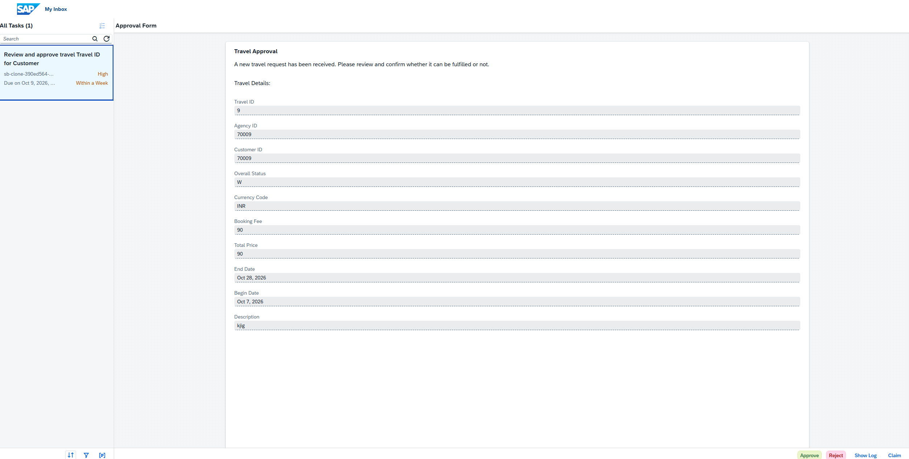

23. Monitor Workflow Instances

Open SAP Build -> Monitoring -> Processes and Workflows.

Open Travel Approval Processing.

Filter by Running, Error, or Completed.

Open an instance and inspect Logs to see each executed step.

Open Context to confirm startEvent.travelContext values.

Use the instance ID printed by CAP to correlate the application request with the workflow instance.
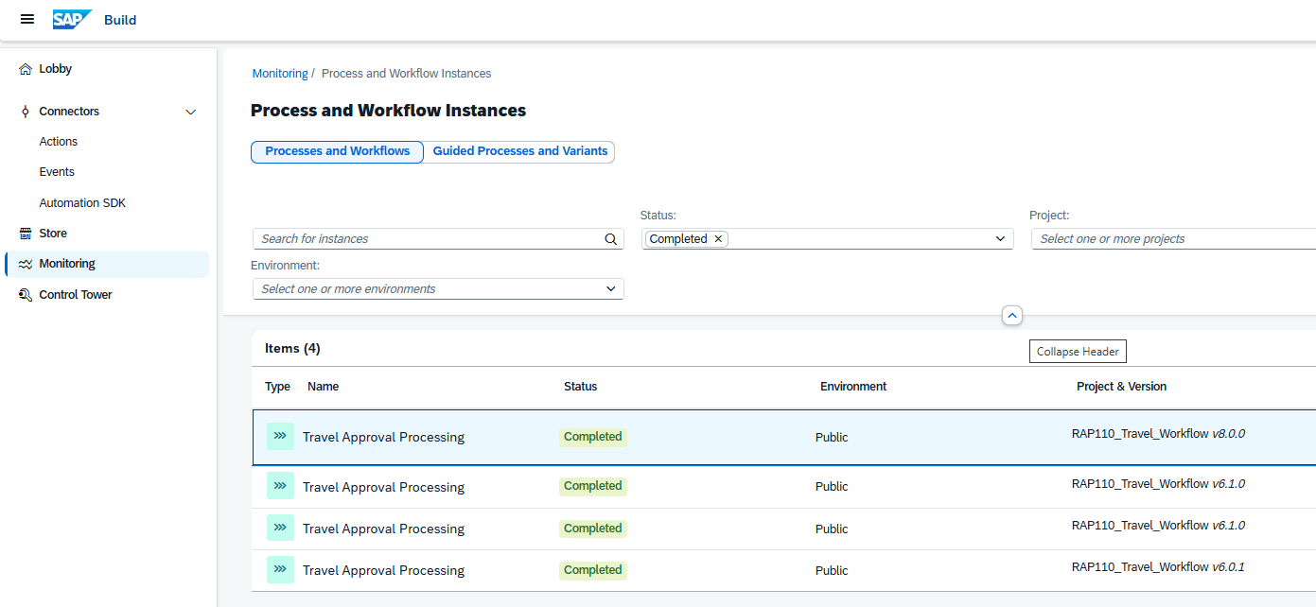
Figure 4. Completed Travel Approval Processing instance.

24. Validate in the HDI Container

Open SAP HANA Database Explorer and refresh CAPWF-db.

Open the Travel table data.

Locate the Travel ID used in the test.

Confirm W before approval.

Confirm A after approval or R after rejection.

Compare the result with the Fiori List Report.

What Broke, Why It Broke, and the Fix
Symptom | Root cause | Fix
Fiori showed more records than BPA/HANA | Different HDI containers were used | Bind local hybrid runtime to CAPWF-db.
Port 4004 already in use | An old cds process was still running | pkill -f cds, then start one runtime.
Actions returned 404 route do not exist | CAPWF-srv was stopped | cf start CAPWF-srv and confirm 1/1 running.
Metadata returned Unauthorized | XSUAA was protecting the deployed service | Use OAuth2ClientCredentials in CAPWF-srv destination.
BPA trigger returned invalid_client | CAPWF-auth credentials were used instead of BPA service-key credentials | Use cf service-key BPA cap-bpa-key values.
Workflow URL was Invalid URL | Environment variables were missing after BAS re-login | Export variables in the same terminal before cds watch.
Workflow instance existed but My Inbox was empty | Started By resolved to the technical OAuth client | Use an explicit recipient or dynamic ApproverEmail.
Action Inputs were blank | Process node referenced a removed Action dependency | Delete and re-add the node from the active dependency.
Travel ID sorting was inconsistent | Presentation Variant did not reference the LineItem visualization | Add Visualizations: ['@UI.LineItem'].
SAVE handler received data differently than CREATE | Fiori used draft activation | Use after SAVE and req.data.

Conclusion
The solution combines Fiori Elements for data entry, CAP for service logic, HANA Cloud for persistence, and SAP Build Process Automation for approval. Success depends on aligning code, runtime state, destinations, credentials, recipients, dependencies, and HDI bindings. Once aligned, users can create, approve or reject, and view Travel requests in one application.
For similar integrations, test each connection independently: Fiori–CAP, CAP–HANA, CAP–BPA, BPA–CAP Actions, and task assignment. This turns a complex landscape into manageable checkpoints.

References
- SAP Help: SAP Build Process Automation authorizations
- SAP Help: SAP Business Application Studio roles
- SAP Help: API Keys
- SAP Help: Execute an API Trigger
- SAP Help: Use API Keys
- SAP Help: Configure an API Trigger to Start a Process

